Liability Waiver Form
Equine Assisted Learning & Mindfulness – Stephanie Van De Ven
Owner & Facilitator: Stephanie Van De Ven
Barn/Address: Greenfields Stables West, Ayr Ontario (Bright) owned by Sandy Noseworthy.
Located: 887593 Township Road 11, Bright Ontario Canada
This agreement is between: (Participants Name)
And Spirit’s Owner: Stephanie Van De Ven
For the purposes of Equine Assisted Learning and Mindfulness Sessions with Spirit, Riding Lessons with Spirit and an approved, certified instructor, or Part-Board.
Accidents/Injuries & Insurance:
Stephanie Van De Ven or Greenfields Stables West is not responsible for any accident, or any injury incurred while with Spirit, at the farm, on premise, or in the barn. You agree that you assume all liability of injuries, and Stephanie or the Farm where Spirit lives will not be sued, or expected to pay for any injuries related to Spirit, or the farm as whole. Stephanie and Spirit are fully insured.
Safety: Safety is a top priority for participants and Spirit.
- Anyone paying for a mindfulness session with Spirit will always wear a helmet & rubber boots or hiking boots with rubber soles.
- Safety in the arena, in the barn, outside, or in the barn is to be adhered to at all times. In the event that Stephanie feels there is an unsafe situation, sessions will end immediately.
- Farm Address: 88597 Township Road 11, Bright Ontario ( Greenfields Stables West)
Website: www.themindfulmama.ca

By Signing Below, all parties agree to the terms and conditions of this waiver:
Participant: _______________________________ Date__________________________________
Owner/Facilitator: _________________________ Date __________________________________

Agreement of Fees, Safety & Cancellation
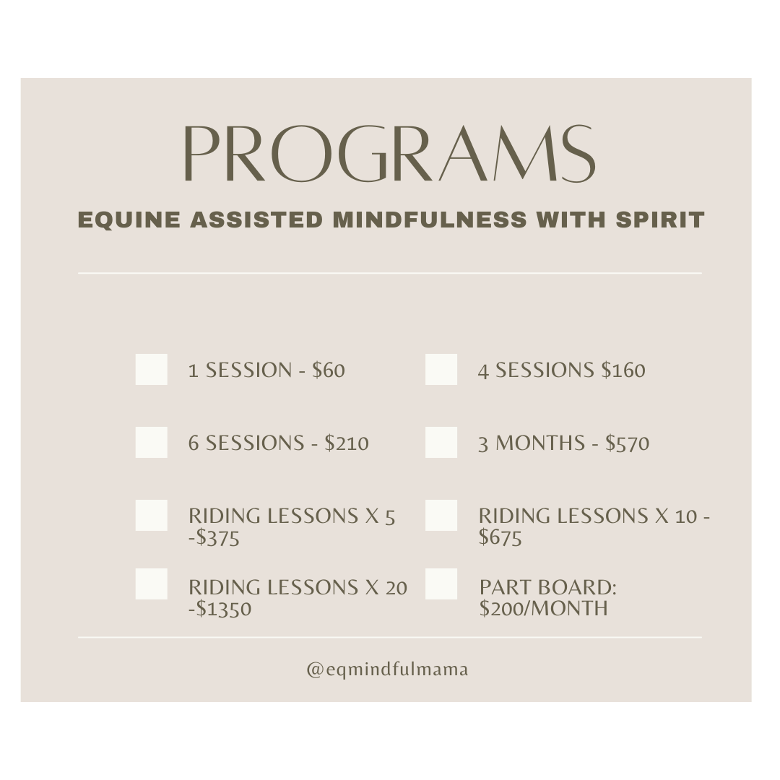
Please check which program you have chosen to enroll your children, or yourself in:

Payment: All sessions and riding lessons must be paid up front, as a deposit to secure and hold your spot. Once payment is received, it is non-refundable.
Part Board: $200/monthly – due on the first of every month by e-transfer to: asktrustgrow@gmail.com
Cancellations: If you miss a session or cancel one for any reason, there are no complimentary make-up dates or times. These times are specifically set aside for your family, and a lot of work, organization and time goes into each and every session, so please ensure you are able to attend.
Exceptions: In the event of inclement weather in the Winter, both parties agree to communicate and cancel if needed. When this happens, Stephanie will try to make up sessions but due to a very busy schedule, this may not always be possible. A minimum of 2 hours notice must be given., and confirmed by both parties.
Note: Should Stephanie or Riding Lessons need to cancel a session for any reason, without a doubt, it will be made up without any additional fees at a mutually agreeable time and date.
Safety & Rules at the barn: Please check that you agree to each of the following:
O Proper boots (rubber boots) hiking boots, or winter boots with a small heel and rubber soles must be work on the property at all times by anyone in attendance. Absolutely no flip flops, running shoes etc are permitted.
O No guests, visitors or friends may attend unless Stephanie is notified in advance and approves. Waivers must always be signed prior to.
O Please ensure you or your child always has extra clothing, water, and layers for the Winter time. While we are inside mostly, we may go outside and it gets a little colder.
O After each session with Spirit, you are welcome to enjoy the farm, but you must be careful and younger children/siblings are not permitted to run around.
O No dogs are permitted on the farm.
O Parents are always welcome to stay, but must also be mindful that there are 40+ horses on the farm, and need to wear proper boots.
O Please arrive on time for your session. Earlier is not needed – Stephanie will have everything ready on time to start promptly.
O Spirit loves snacks! If you feel like you would like to bring snacks, he loves carrots and apples. Please ensure snacks are cut up into approximately 1-inch pieces to prevent choking.
O If Stephanie feels that a session is not safe, students are not being respectful, or there are any challenges which she is not certified or experienced to manage – the session will end.

By Signing Below, all parties agree to the terms and conditions of this waiver:
Participant: _______________________________ Date__________________________________
Owner/Facilitator: _________________________ Date __________________________________

Your Contact Information:

Parent Name:
Cell Phone:
Email:
--
Parent Name:
Cell Phone:
Email:
--
Student Name:
Age:
Challenges or anything Stephanie should know in advance?

Student Name:
Age:
Challenges or anything Stephanie should know in advance?

Anything else to add?

